ACS Indiana Section Hosts a Record-Breaking 2026 “Think Like a Molecule” Poster Session at Ball State University

by Linda V. Osborn
On November 5, 2026, the ACS Indiana Section proudly hosted the annual Think Like a Molecule undergraduate and graduate research poster session at Ball State University’s Foundational Sciences Building, Room FB-142, Muncie, IN. The event ran from 5:00–9:00 PM and brought together an inspiring community of emerging scientists, faculty mentors, and dedicated judges from across the state.
This year’s session was our largest yet, featuring 74 posters, including 63 undergraduate presenters and 11 graduate students, representing 10 Indiana universities. We were honored to have 24 volunteer judges, each of whom spent thoughtful, focused time with the students. Their engagement elevated the experience and helped make the evening truly special. Amazingly, 100% of the students and judges showed up for this special event!

Outstanding Hosting by Ball State University
We extend our deepest appreciation to Dr. Mary Konkle, whose leadership made the event run seamlessly, and to Dr. Jesse Tye, Chair of the Department of Chemistry, along with the entire Ball State Chemistry faculty and staff. Their warm hospitality and excellent accommodations in the Foundational Sciences Building created an ideal environment for scientific exchange and celebration.
Special thanks also go to:
- Vannessa Santana, whose on-site support was invaluable throughout the event
- Alexandria Temerius, who expertly entered scores and audited results to ensure accurate award determinations
Their behind-the-scenes work made the evening smooth, welcoming, and well-organized.

Keynote Speakers Who Inspired the Room
Dr. Alexandria Quillin, Ball State alumna (2020), who earned her Ph.D., at Washington University in St. Louis (2025), returned to deliver an engaging keynote address during the awards ceremony while scores were being tabulated. Her message resonated deeply with students.
We also thank Dr. Christine Skaggs, R& D scientist at Eli Lilly, for sharing the benefits of joining ACS early in one’s scientific journey. Her example, encouragement and insights will hopefully yield new ACS members!

A Night of Celebration and Achievement
The awards ceremony was filled with excitement, with many more students staying this year compared to last. Seventeen students received awards receiving a total of $1,575.00 in prize funds.
Additionally, three students who registered early received a $50 early-registration award:
- Roee Sela, DePauw University
- Andrew Sammelson, Ball State University
- Arianna Gillespie, University of Indianapolis
Below is the full list of winners, organized by award category:

Grand Prize
- Poster 48 — Alexey Shinkevich, Ball State University

Dean’s Awards
Dean’s Award – First Place
- Poster 73 — Hailee Campbell, BSU
Dean’s Award – Second Place
- Poster 36 — Georgeanna Ashworth, Marian University
- Poster 60 — Corbin Moake, BSU
Dean’s Award – Third Place
- Poster 14 — Kaitlyn Walls, IU Indianapolis

ACS Chair’s Awards
ACS Chair’s Award – First Place
- Poster 30 — Donovan Doolittle, Marian University
ACS Chair’s Award – Second Place
- Poster 3 — Roee Sela, DePauw University
ACS Chair’s Award – Third Place
- Poster 28 — Cristina Avello & Priscila Espinoza, Marian University

Kurek Awards
Kurek Award – First Place
- Poster 1 — Jackson Hopkins, Butler University
Kurek Award – Second Place
- Poster 4 — Andrew Sammelson, BSU
- Poster 68 — Ximo Leon, Marian University / IUSM
Kurek Award – Third Place
- Poster 58 — Kyle Petersen, BSU
- Poster 59 — Caitlyn Newmark, BSU

Photos and Memories
Thanks to JB Bilbrey, Communications Manager for the College of Sciences and Humanities at Ball State, we have a beautiful collection of professional photos from the event:
Ball State Photographer Gallery https://ballstate.box.com/s/8mz9jjg0phgd0ralk6pe2stm3hnd3m42
Additional photos shared by attendees can be viewed here:
https://drive.google.com/drive/folders/1hqgjoptZ7OHvWkKgNKSm9yda5JL6AvAb?usp=sharing

Looking Ahead
We extend heartfelt thanks to everyone who contributed to the success of this year’s Think Like a Molecule event — judges, faculty, staff, students, and volunteers. Your enthusiasm and commitment to supporting young scientists continue to strengthen our statewide chemistry community.
We will also be sending judges’ written comments anonymously to the student presenters so they can benefit from their thoughtful feedback.
Until next year, keep Thinking Like a Molecule!
Photos to include as part of the article:
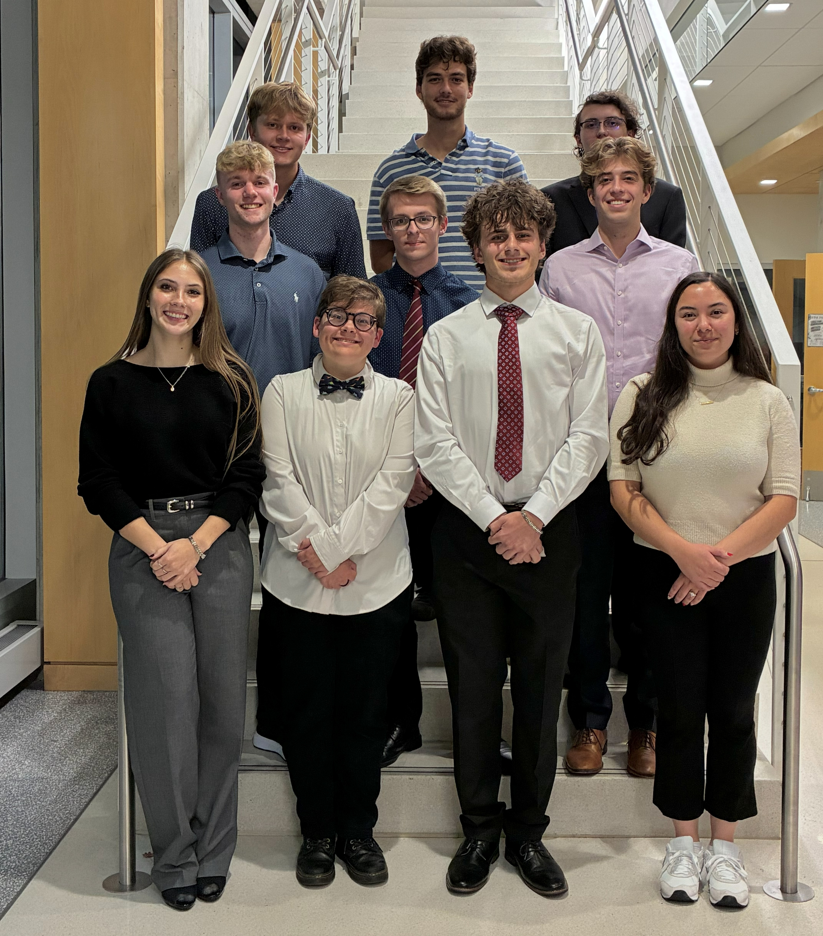
Some of the ACS “Think Like a Molecule” Poster Session talented Winners.
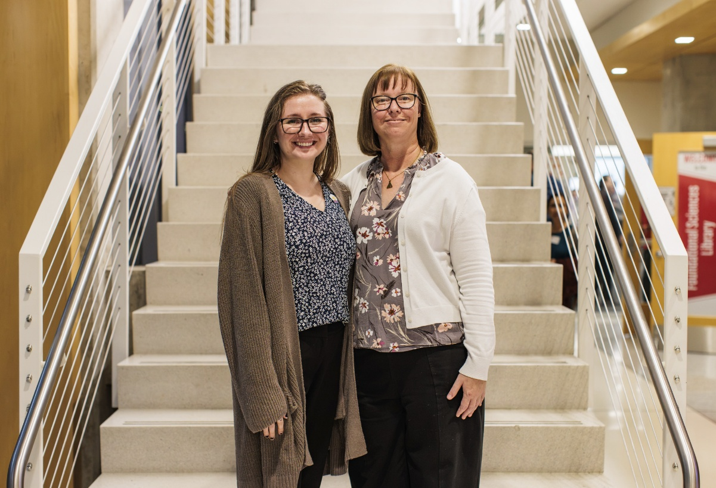
Former student, Dr. Alexandria Quillin (left), the keynote speaker, and Dr. Mary Konkle, Associate Professor of Chemistry at Ball State University.
